**MASTER MAINTENANCE MODULE**

**HumanResource Management**

DreamApps Human Resource Management solution significantly reduces the time your HR department spends on administrative tasks and allows them to focus on strategic initiatives that impact the growth of your business. Following HR best practices and incorporating streamlined workflows, the system simplifies the administration of employee benefits and open enrollment, compliance reporting and tracking employee details and events.

**Overview**

DreamApps Human Resource Management module makes your life easy to manage all the necessary data you need about your employee. This module keeps track of personal data of each employee and derives various result and reports according your need. It also helps your payrolls be accurate and on time by spending lesser administrative time and cost to prepare.

With **Human Resource Management (HRM),** you can:

* Attach Picture and Signature of each employee is stored and tracked so that authentication is fully secured.
* Store Personal Info of each employee as you must need in your employee management
* Qualification Info of your employees
* Work Experience Info
* Performance Appraisal with different methods

Whether you're simply looking for an effective way to automate employee data, or you require a more sophisticated HR and Payroll Management System, DreamApps Human Resource Management Solutions offers the complete Human Resource Management software.

**HR_Master maintenance Module**

In HR module you will get

|  |  |
| --- | --- |
| **Entry Mode= Master maintenance (Employee Master)** | 1. General 2. Education 3. Experience(Work) 4. Document 5. Training Information 6. Imaged Upload 7. References 8. Employees 9. Family |
| **Entry Mode (Employment Information)** | After complete entry   1. Rate (Other allowance) 2. Pay package |
| **Setup** | 1. Address Type 2. Budget Code 3. Budget sub-code 4. Courses 5. Department 6. Designation 7. District 8. Division 9. Employee Group 10. Exam Type 11. Expense head 12. Feet 13. Great 14. Inch 15. Job status 16. Location 17. Management Level 18. Nationality 19. Night stay 20. Place of Travel 21. Planning Year 22. Port 23. Rank 24. Religion 25. Section 26. Sub Rank 27. Weight 28. Zone |

***Employee Master***

1. **General**

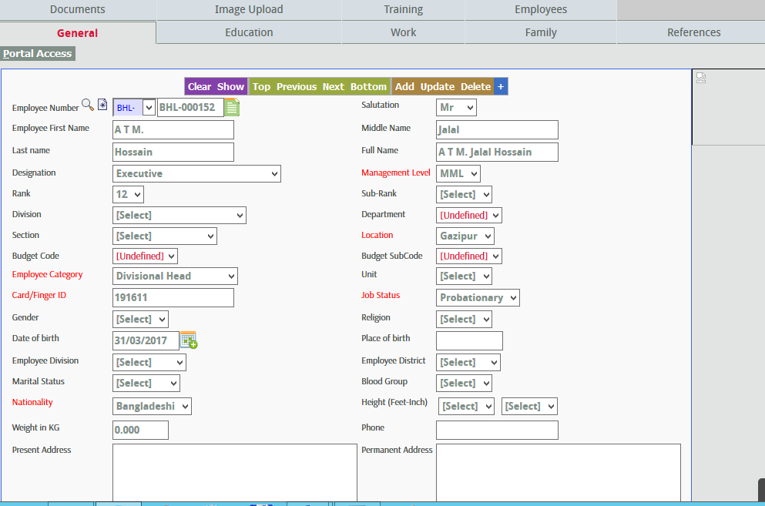

At this field of employee master’s general section, you can keep all the necessary general information’s of your employees. Let see what field are associated with purchase requisition entry and what necessary data we have to input in these field.

1. **Employee Number:** It’s an auto generated employee number which is automatically generated from system.
2. **Salutation:** Mr, Mrs etc
3. **Employee First Name:** In this field we have to input short name of the employee.
4. **Middle name:** Middle name of the employee. (It is not compulsory)
5. **Last Name:** Last name of the employee.
6. **Full Name:** Full name of the employee.
7. **Designation:** Designation of the employee. Suppose, Head of Finance. In setup designation must be **link** to Rank**(Alternate Code)**.
8. **Management Level:** Management level divided into this category (Top, Mid, Senior).
9. **Rank:** This rank has been given according to designation.
10. **Sub rank:** Sub-rank must be **link** to rank **(Alternate code)**.
11. **Division:** Employee are working in which division in the company.
12. **Department:** Department must be link to Division (**Alternate code**).
13. **Section:** Section must be link with Department (**Alternate code**).
14. **Location:** Employee is working in which Location.
15. **Budget code:** Budget code must be link with Location (**Alternate code**).
16. **Budget sub code:** In setup screen Budget sub code must be Link to Budget code (**Alternate code**) and Department (**Property List**).
17. **Employee Category:** Which type of employee they are. Suppose senior staff, head, staff etc.
18. **Unit:** Which employee comes from which unit.
19. **Card/Finger ID:** Employee finger ID when employee punch in the in-out time.
20. **Job status:** Suppose, Permanent, Temporary, Probationary etc.
21. **Gender:** Gender means male, female etc.
22. **Religion:** It means which religious view follow employee,
23. **Date of Birth:** Date of birth of the employee.
24. **Place of Birth:** Place of birth of the employee.
25. **Employee Division:** ? Problem
26. **Employee District:** Employee district must be Link with employee Division (**Alternate code**).
27. **Marital Status:** Marital status of the employee.
28. **Blood Group:** Blood group of the employee.
29. **Nationality:** Nationality of the employee.
30. **Height:** Height measure according to feet and inch.
31. **Weight in KG:** Employee weight in kg.
32. **Phone:** Employee active TNT number.
33. **Present Address:** Present address of the employee
34. **Permanent Address:** Permanent address of the employee.
35. **Fax:** Employee organizational Fax.
36. **Office Mobile:** Official phone number of that employee.
37. **Personal number:** Employee personal phone number.
38. **Email:** Organizational email address of that employee.
39. **Passport number:** If employee have a passport.
40. **Issue date:** Passport issue date of that particular employee.
41. **Expiry Date:** Expire date of the passport.
42. **National ID:** National ID number of that employee.
43. **Food subsidy:** It is a deduction item. Line associate can take lunch 100 %( Company will bear cost) free of cost. Executive will get 75% subsidy, it means company will cut 25% amount from employee salary. It should be included in each of the employee because of monthly food payroll process.
44. **Supervisor:** Include supervisor of that employee.
45. **Name:** When employee want leave they need to get permission from the Leave authority team. Here include the name of leave authority.
46. **Link:** This is the picture link of that employee.
47. **Education**

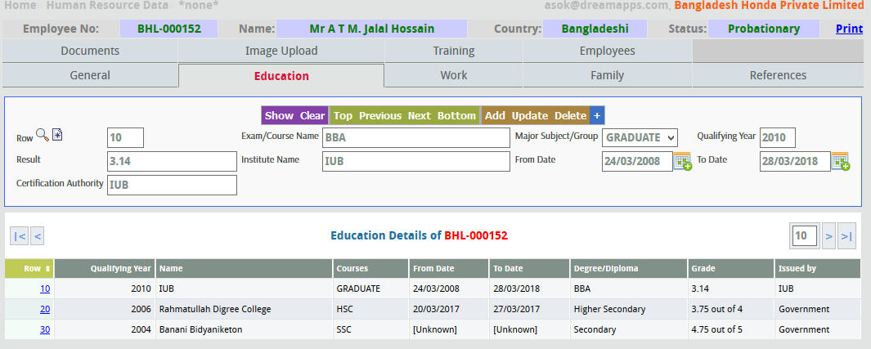

You can keep all the educational information about your employees here, in this section.

* 1. **Row:** It is auto generated by the machine.
  2. **Qualifying Year:** Year of educational qualification of the employee.
  3. **Institute:** Name of the institute from where the employee passed.
  4. **Courses:** Courses done by the employee.
  5. **From Date:** Education starting date of the institution where the employee studied.
  6. **To Date:** Education ending date of the institution where the employee studied.
  7. **Degree/Diploma:** Name of the degree earned by the employee.
  8. **Graduation:** If the employee have a graduation or nor, that should be mentioned here.

1. **Experience** (Work)

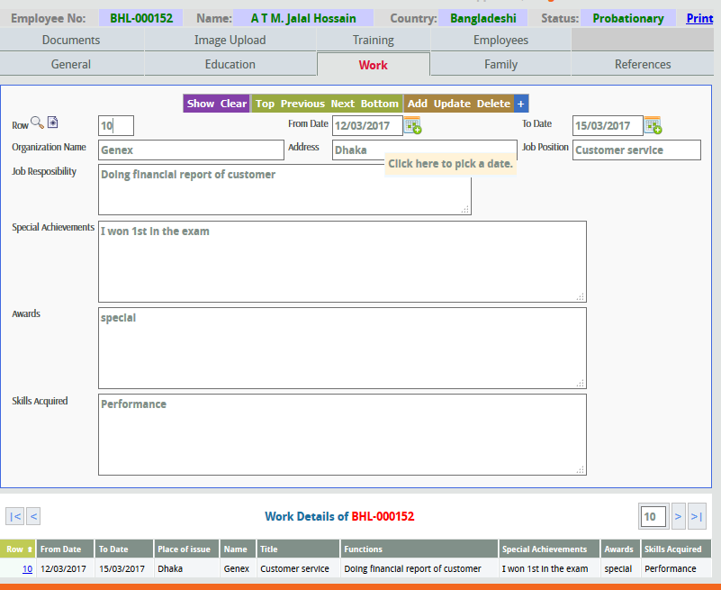

All the records of experiences gained by the employee’s are kept in this section.

* 1. **Row:** It is auto generated by the machine.
  2. **From Date:** Past **s**tarting date of the institution where the employee gained an experience.
  3. **To Date:** Pastending date of the institution where the employee gained an experience.
  4. **Company:** Name of the company where the employee gained experience.
  5. **Address:** Address of the company where the employee gained experience.
  6. **Occupation:** Occupation in the company where the employee gained experience.
  7. **Country:** Name of the country of the company where the employee gained experience.
  8. **Salary:** Salary of the employee where he gained the experience.
  9. **Remarks:**  Any additional information about the past experience of the employee.

1. **Document**

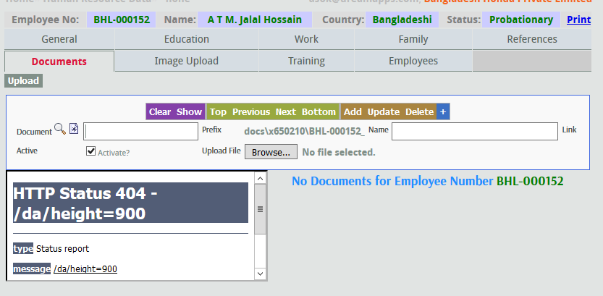

1. **Document No:** Any document of any employee can be saved here and for that first you have to give a document number in this box.
2. **Name:** Name of the document will be shown here, you can change the name of the document if you want.
3. **Upload File:** By pressing the ‘Browse’ button on the right side of this box will let you select the file which you want to save and by selecting that file you can upload the file.

1. **Training Information**

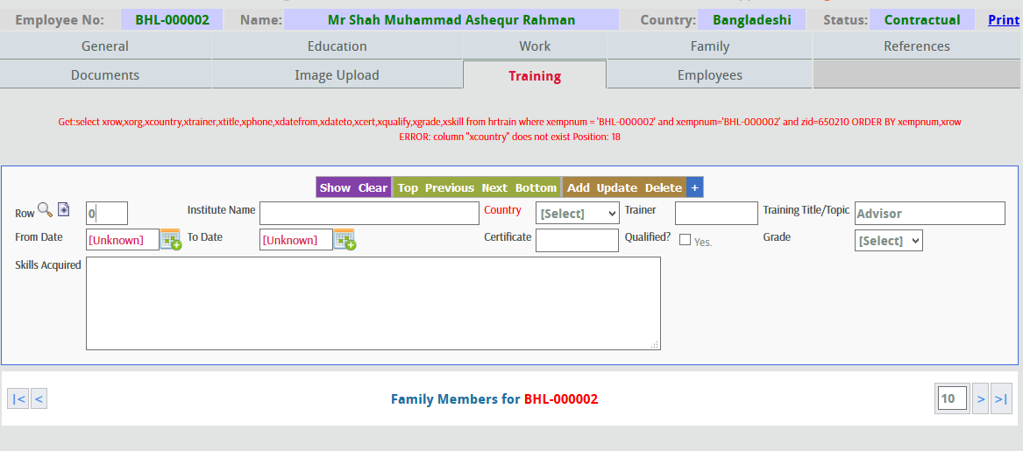

All the training information’s gained by any employee, are kept here.

1. **Row:** It is auto generated by the machine.
2. **Name of Training:** Name of the training given to the employee
3. **Training Institute/Body:** Place of training
4. **Type of Training:** The type of training whether it is oral or written
5. **From Date:** Starting date of training
6. **To Date:** Ending date of training
7. **Duration of Training:** Total time duration of the training
8. **Result:** Result of the training taken by the employee.
9. **Achievement:** The entire achievement of the candidates
10. **Confirm Status:** Confirm status which is given from the organization
11. **Image Upload**

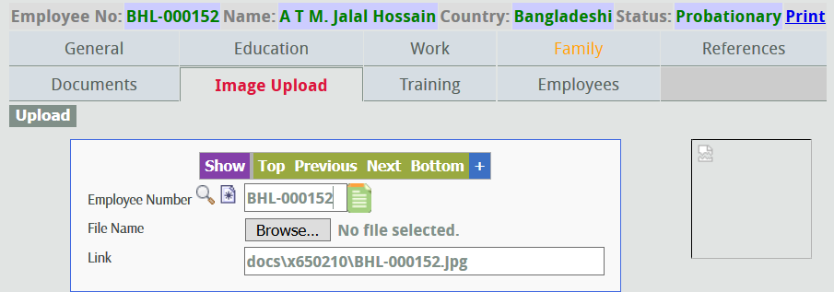

1. **Employee Code:** Employee code of the employee should be given here for the Image Upload of the employee.
2. **File Name:** Image file name should be given here from the search button which is on the right side of the File Name box.
3. **Link:**Link of the image file will be shown here after the image upload.
4. **References**

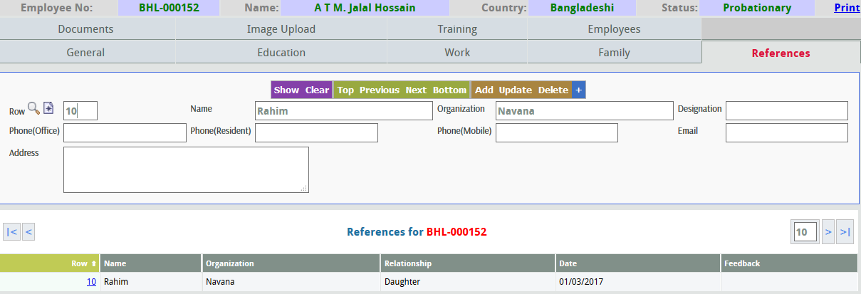

Information’s about the references given by the employee are kept in here.

1. **Row:** It is auto generated by the machine.
2. **Name:** Name of the referrer.
3. **Company:** Name of the company of the referrer.
4. **Occupation:** Occupation of the referrer.
5. **Relationship:** Relationship with the referrer.
6. **Feedback:** Any feedback given by the referrer to the employee is mentioned here.
7. **Employees**

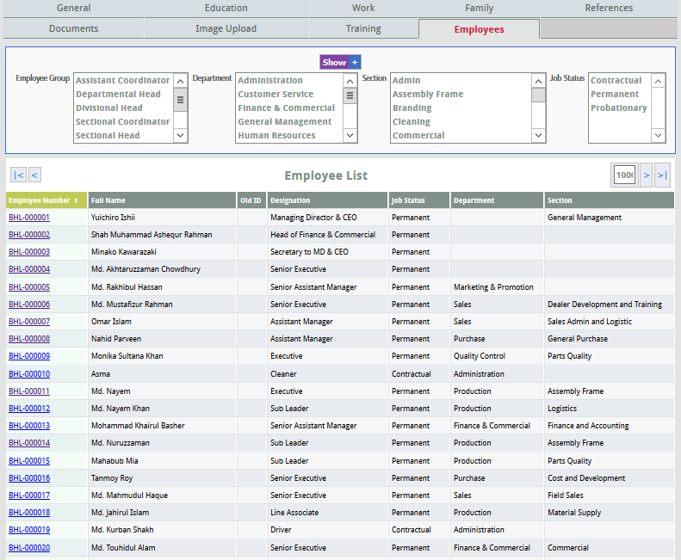

All the employees’ information of the organization can be found here by selecting the ‘Employee Category’, ‘Department’ and the ‘Designation’.

1. **Family**

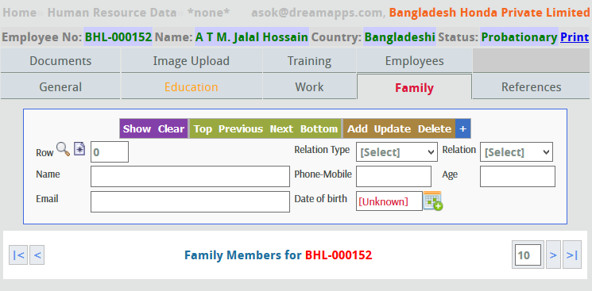

All the information of the employees family members are kept here. After inputting all the necessary information, you have to click the ‘Add’ button and the information for one member will be saves. For saving another members information, you have to click the ‘Clear’ button and then give all the information’s and then again click ‘Add’.

1. **Reports**

|  |  |
| --- | --- |
| **Reports (Master maintenance)** | 1. Job Status Wise Employee List 2. Designation Wise Employee List 3. Section Wise Employee List 4. Religion Wise Employee List 5. Gender Wise Employee List 6. Employee Job Duration 7. Employee wise Status List 8. Employee Count 9. Employee Details Report 10. Level wise total employee list 11. Supervisor wise employee list |

1. Job Status Wise Employee List: can see job status wise employee list. Suppose , Permanent / Temporary / Probationary etc.

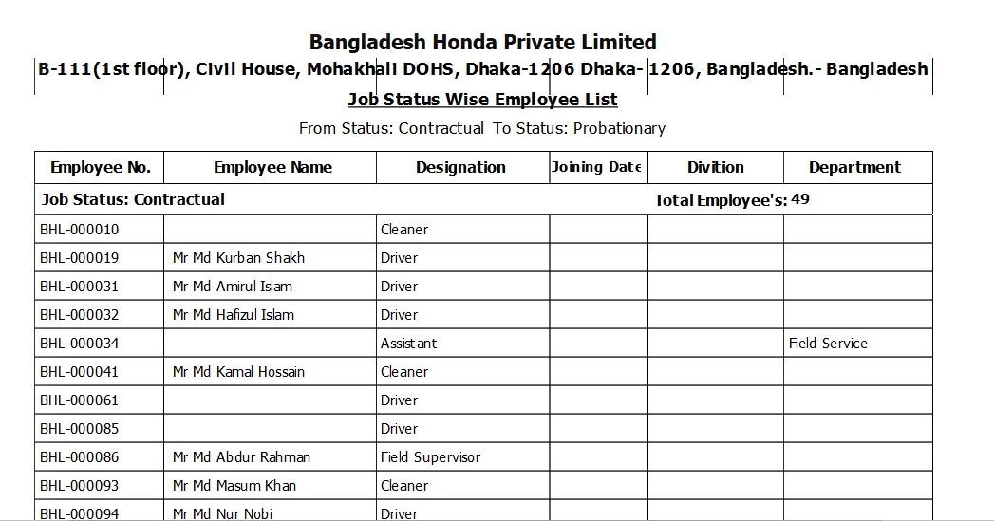

1. Designation Wise employee list: Can see designation to designation wise employee list

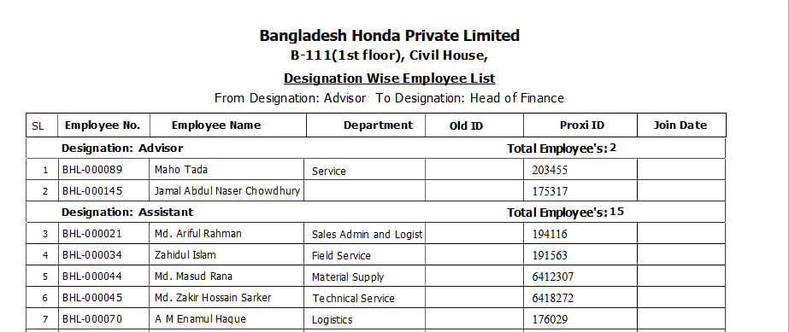

1. Section wise employee list: They can see employee list section to section wise

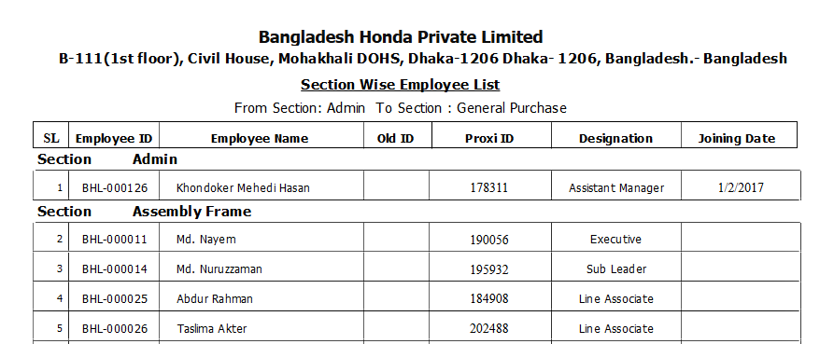

1. Religion wise employee list: they can see employee list religion to religion wise

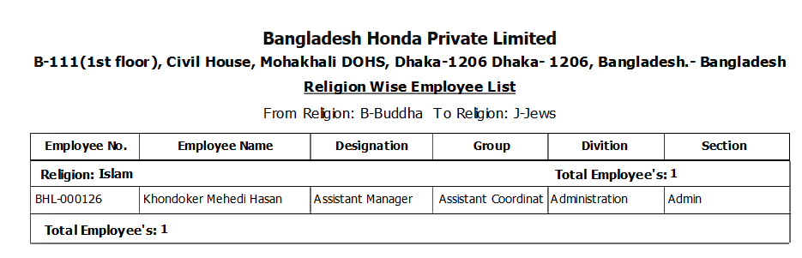

1. Gender wise employee list : Can see gender to gender wise employee list

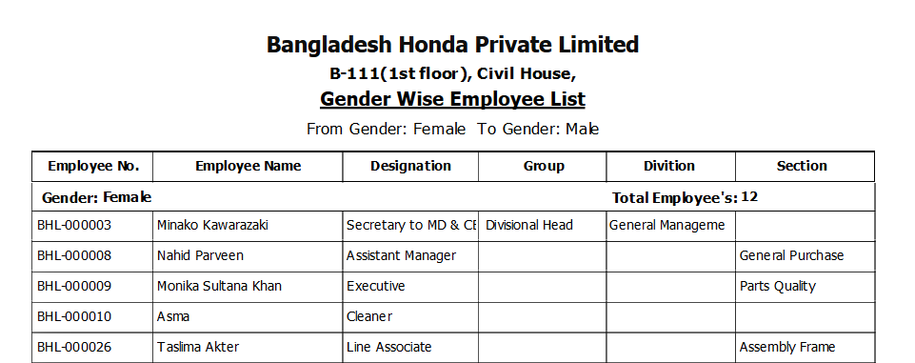

1. Employee Job Duration:

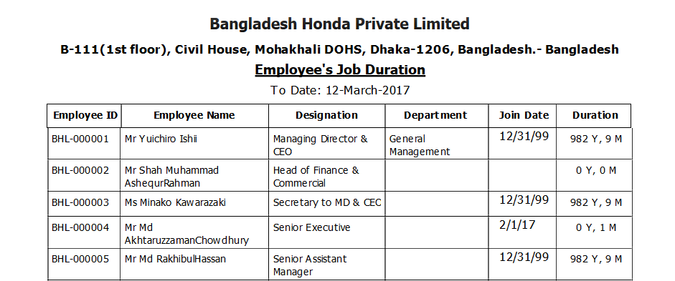

1. Employee wise status list: Employee to employee wise status(Active/Inactive) list cansee

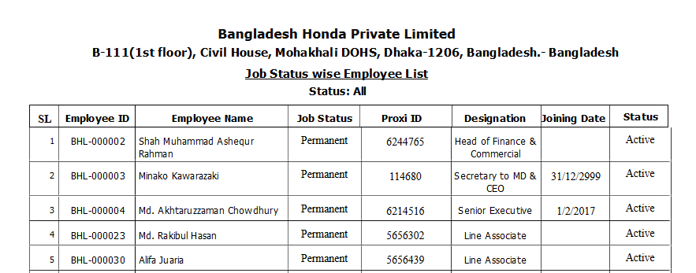

1. Employee count: In this report there has 6 parameter. Department, Section, Employee, Location, Category, Gender wise count employee.

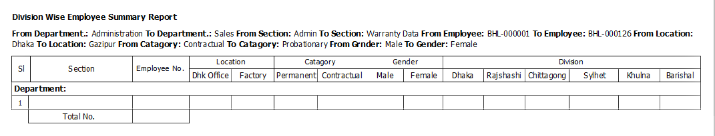

1. Employee Details report: They can get employee detail report Department and section wise.

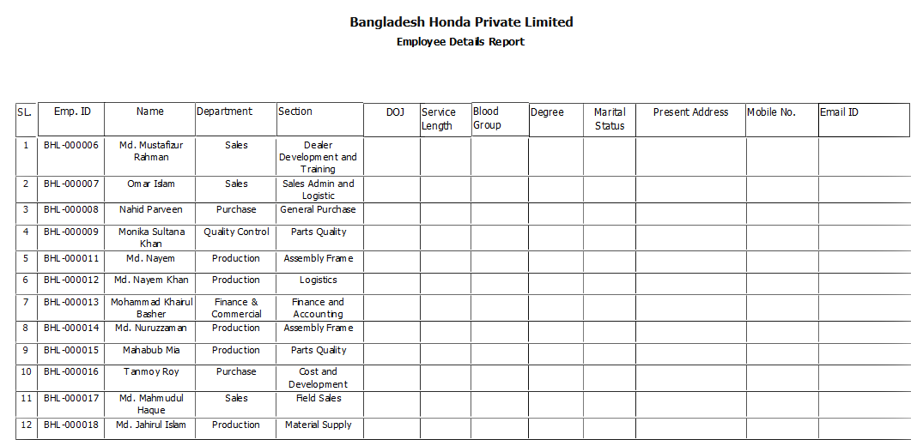

1. Level wise total employee list: Management Level, Salary rank and Designation wise organization can get detail report of the employee.

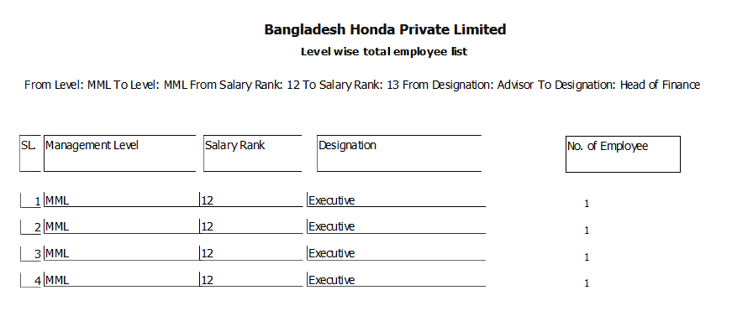

1. Supervisor wise employee list: here organization can get Supervisor and department wise employee list.

